Switchback Ivy and Untitled Cross 2
Friday, September 02, 2016 7:11 p.m.
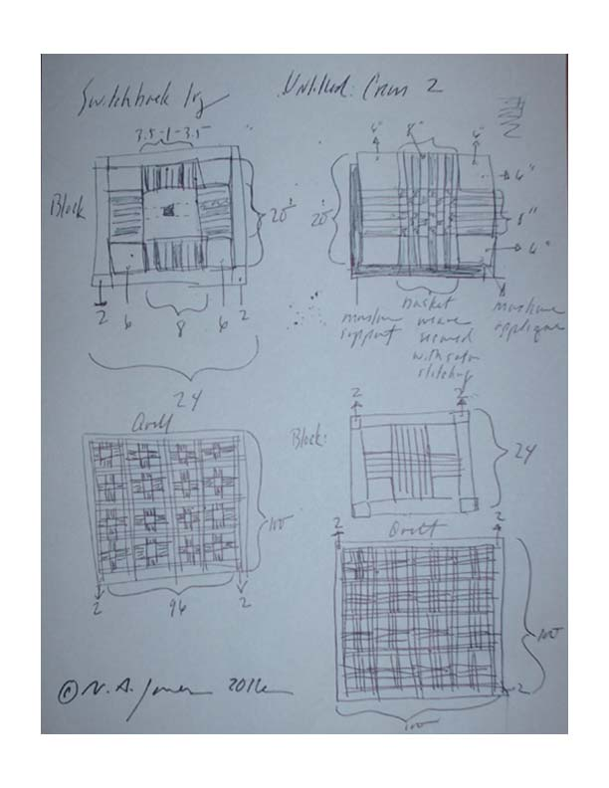
©N.A. Jones 2016

