St. Patrick’s Cross
Friday, September 02, 2016 7:13 p.m.
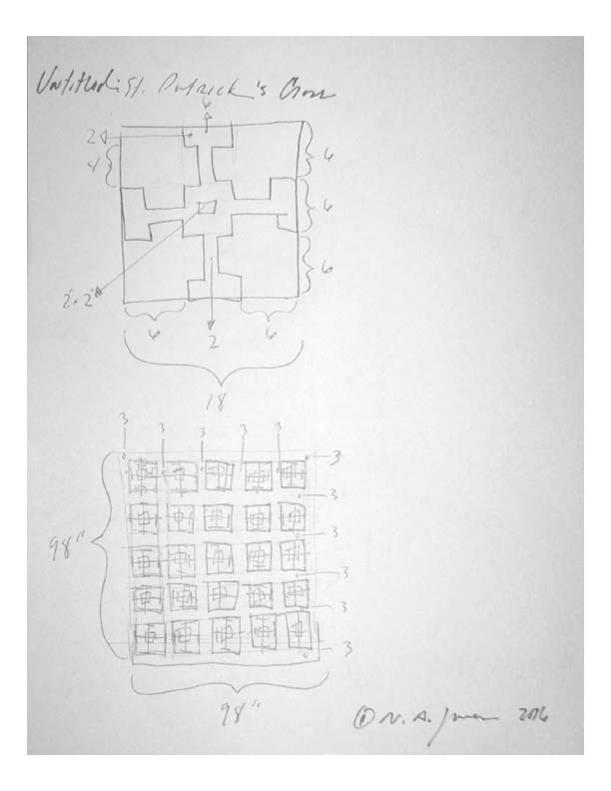
© N.A. Jones 2016

