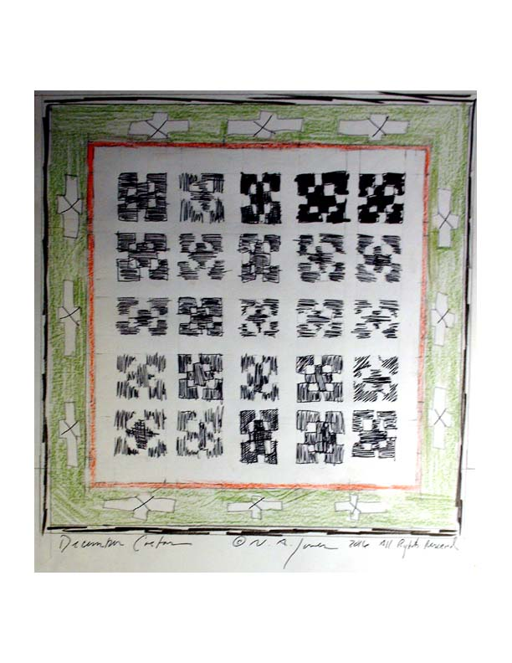

December Cactus 2016

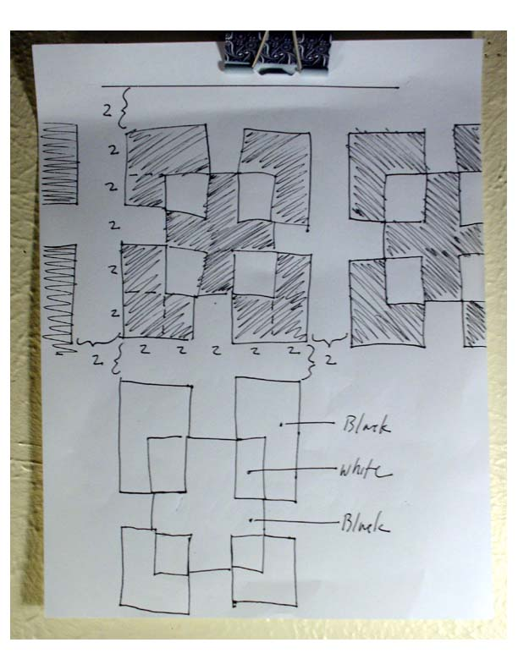

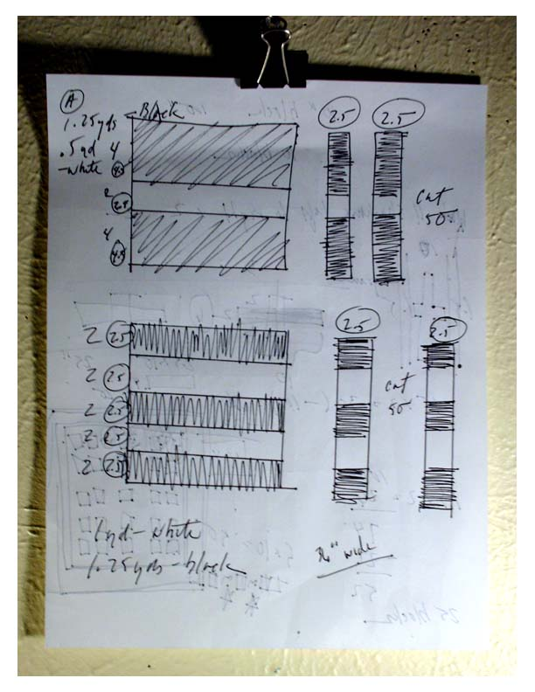

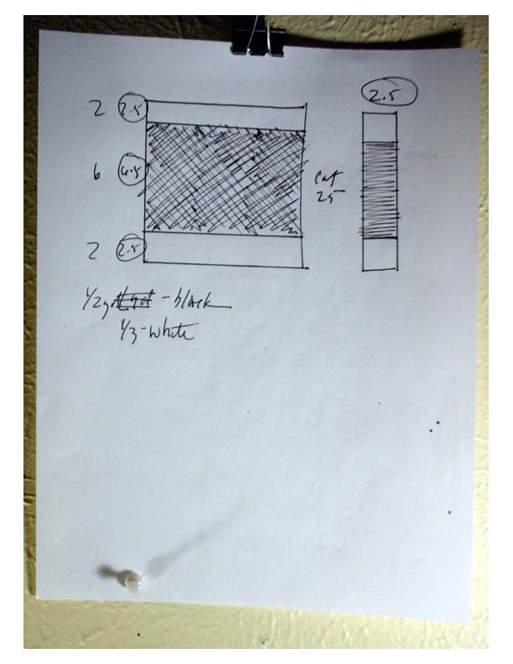

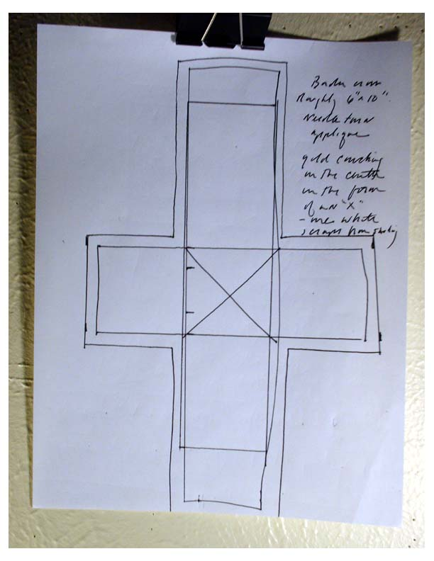

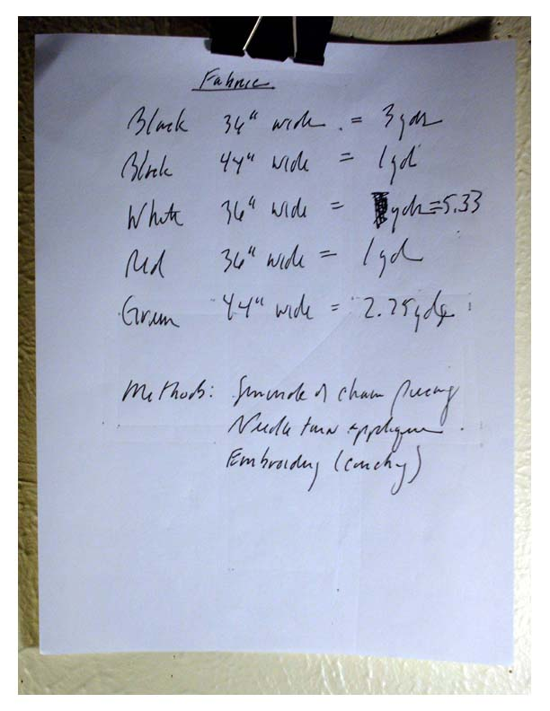

Notes:
Using the color sketch on the first page, the apparent vertical key and horizontal key are the same: 1.5-10-1.5-2-10-2-10-3-10-3-10-2-10-2-1.5-10-1.5
(These are the measurements for the objects in the finished quilt.)
The construction vertical and horizontal keys are the same:
2-10.5-2-2.5-10.5-2.5-10.5-3.5-10.5-3.5-10.5-2.5-10.5-2.5-2-10.5-2
(These are the measurements for the quilt components before assembly.)
All measurements are in inches.
The fabric list consists of rough estimates.
Mind your use of length and width with the 36” wide white. Cut sashing first then cut for the long passages across to assemble the center.
Measurements include ample room for adjustments.
This pattern draws on an ancient design that comes from an iconic painting of St. Nicholas. The central motif sources the Saint’s garb as he holds the Holy Bible.
When buying supplies do not forget the gold embroidery floss and contrasting anchor.
Image reference found in The Practical Kabbalah Guidebook by C.J.M. Hopking on page 105.

©N.A. Jones 2016 All Rights Reserved

