Pattern: Cross 1
Difficulty: Easy
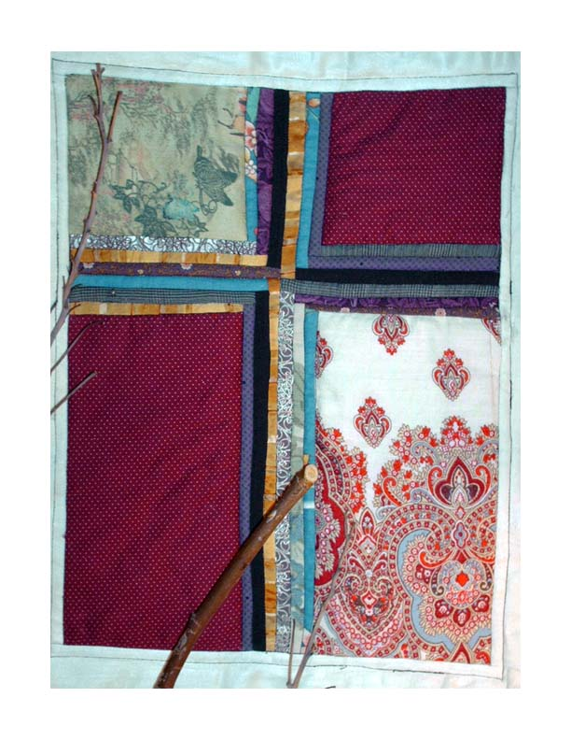
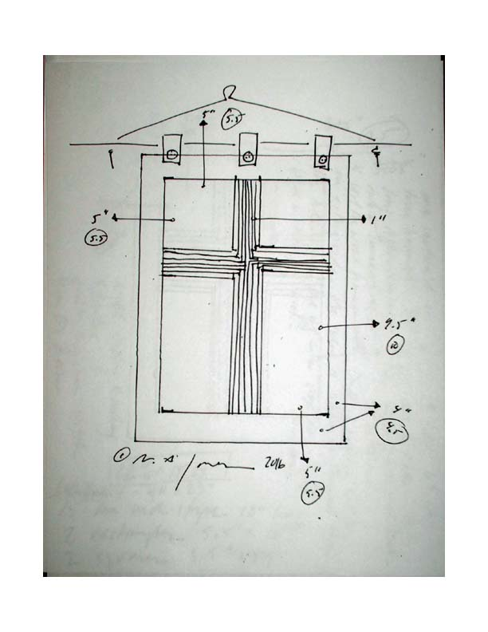
Materials and Notes
15 one-inch strips of various colors measuring 12 inches in length
2 rectangles measuring 5.5” x 10”
2 squares measuring 5.5” in width and height.
4 sections for the border measuring 4”x 23”
3 tabs 6” long – use 2” ribbon and affix to the front and the back with buttons directly sewn on
1 section of high loft batting measuring at least 25”x 20”
1 section of backing measuring at least 25” x 20”
1 section of a tree branch measuring 32” long. After harvesting, rub linseed oil into the wood to seal it from insects. Drill two holes 6” in on either side. Use twine or ribbon to thread through the hole and tie off in a loop to form a hanging hook.
Assembly:
Using the one-inch strips, form French braids at least three layers deep along the two sides of the rectangles and the squares. (See diagram below.) Carefully press the seams to one side.
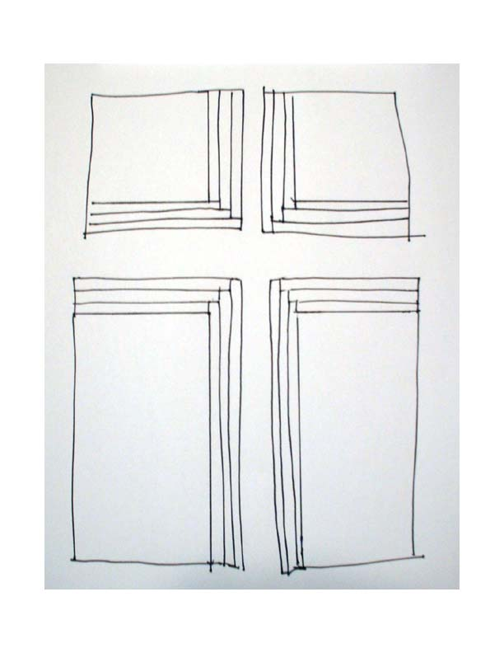

Join the sides first to form the left and right sections of the cross. Press the seams in one direction. Form the whole cross by a single straight seam through the French braid from bottom to top. Press seams to one side.

How to Make a French Braid Quilt: Two Ways - Craftsy www.craftsy.com › Blog Home › Quilting Blog
Dec 21, 2014 - Blog Home » Quilting Blog » How to Make a French Braid Quilt: Two Ways! ... Have you ever sewn a French braid quilt or quilt block? Also called friendship braids, French braid quilts are sewn from fabric strips in a pattern that gives the illusion of woven strands.
Sash the block with care to the tail ends of the braid.
Form the quilt layers and baste. Simple stitching will leave and understated piece. Taking care to use hi-loft batting will make a relief of the banner. Another strategy is to let the fabric choices speak for themselves. Too much decorative stitching may take attention away from the center design. Still, take a chance and risk if you are inclined.
Attach the binding
Attach tabs.
Secure the banner with the wooden rod.
Hang.
©N.A. Jones 2016

